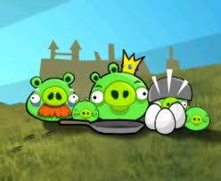

Angry Birds Project
Objective: The objective of this project is to create a working catapult that can be used to measure distance traveled.
You will need to do some research regarding the make-up of your catapult. Your job is to design a catapult that works from house hold materials such as straws, forks, rubber bands, etc… Google catapults or animated catapults and find a design you can model or a helpful website might be:
http://www.livebinders.com/play/play_or_edit?id=142880
We will be testing these in class and discussing many topics related to the catapult including the scientific method, data tables, graphs, vocabulary and types of energy just to name a few. My expectation is that the student creates a fully working catapult and be able to present it to the class.
Example:
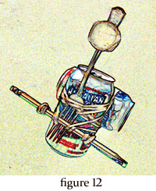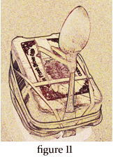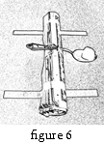

Rubric: 5 4 3 2 1
Creativity

Does it work

Evidence of research

Scientific Method

Design

Data tables

Measurement Graph

Vocabulary

Comparison of catapult

Explanation of how it works

How to get a 5!!!!!
Creativity: Make your catapult original, don’t copy someone else’s. Use different objects, try different things.
Does it work: Test it before you bring it to school. Make sure it can catapult objects of different weights. Testing it will allow for any “fixing” that needs to be done.
Evidence of research: Include a written or typed info sheet on the catapult including what it was used for, when it was used and how it works.
Scientific Method: Include an explanation of the scientific method using your catapult as your experiment. (All 6 steps.)
Design: Include a drawing or diagram of your design.
Data Tables: Include a data table charting all of the data measurements you collected from your trials. Each object should have its own data table. No less than two objects of your choice.
Examples:
Object 1: Marble wt. 15 oz Object 2: Paper clip wt. 7 oz.
Trial | Distance Traveled
1
2
3
4
5

Measurement Graphs: Using your data table include a graph showing each of your catapults trials and its measurements. (Preferably a line graph) Each object should have its own graph.

Vocabulary: Define any new vocabulary words you come across in your research or designing of your catapult. Have to have at least 3- 5 definitions.
Comparison of a catapult: Write a comparison paragraph by choosing one of your classmates’ catapults and compare it to yours. Ex. Materials, distance traveled, design, etc.
Explanation of how it works: Include a typed or hand written explanation of how your catapult works.

All written work should be turned in with a table of contents including:
1. Evidence of research
2. Scientific Method
3. Design
4. Data Tables
5. Measurement Graphs
6. Vocabulary
7. Comparison of a catapult
8. Explanation of how it works

I have included for you:
- A website to assist in your design and to use for your research information.
- Examples of catapults
- A rubric with which you will be graded
- My expectations and how to receive full credit on this project
- An example of the table of contents
- Examples for your data table and line graph

